SWIFT BASICS

1. Types

* Type inference means that this language allots the data type as per the allotted value.

1. Optionals

* Optionals type, which handles the absence of a value.
* Optionals say either "there is a value, and it equals x" or "there isn't a value at all.
* An Optional is a type on its own.
* You can unwrap an optional by appending ! character at the end of the variable/constant as in the next line *print(Value!).*
* To get the contents is called unwrapping .
* *let shortForm: Int? = Int("42")*
* *let longForm: Optional<Int> = Int("42")*

Forced unwrapping in swift 🡪

* using ! we can unwrap but the application will crash if the optional doesn’t have a value.

Optional Binding 🡪

* An optional string is assigned the value. Then in the if-let block, the optional value password is unwrapped and assigned to the variable only if the optional value is not nil. This variable now contains the unwrapped value and can be used within the block's scope.

Optional Chaining 🡪

* This is used while dealing with multiple optional values at once.
* Optional chaining involves verifying at each dependency if instance is nil or not.

Nil Coalescing operator 🡪

* works as shorthand notation for the regular if-else block. If a nil value is found when an optional value is unwrapped, an additional default value is supplied which will be used instead.
* *var text:String?*
* *var output = text ?? "Default value"*

1. to sort an array in descending order 🡪 ages.sort(by:>)
2. 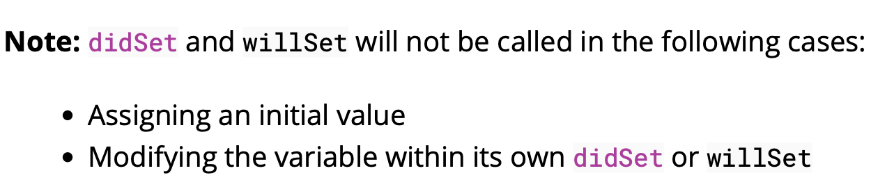**Property Observers 🡪 willSet and didSet**
3. We can use sets as they have constant time lookup and can have better performance than the array.